C:\Users\JESSIC~1\AppData\Local\Temp\SNAGHTMLc2a18f.PNG**NAXT Quick tips**

***Removing*** an unposted reman part will also ***remove*** its outstanding cores!

**OUTSTANDING CORES on a service segment**

When closing a service segment you may see a message like this:

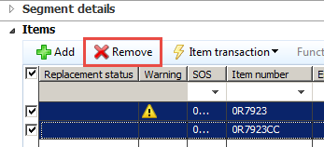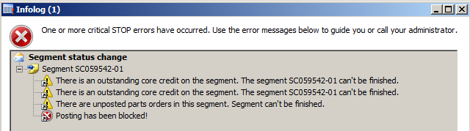***There are There are three ways to remove outstanding cores:***

1. Remove unposted reman items
2. If the item is worn on a machine process a worn core credit
3. If the item is unused process a parts return

POSTED REMAN

POSTED REMAN

C:\Users\JESSIC~1\AppData\Local\Temp\SNAGHTMLc4a585.PNGC:\Users\JESSIC~1\AppData\Local\Temp\SNAGHTMLc451cb.PNGWorn core ***OR*** Parts return

Don’t do **ANYTHING** until you look at the part to see if it is ‘worn’ (used on customer’s machine) or ‘unused’, then follow the steps below accordingly:

POSTED REMAN

|  |  |
| --- | --- |
| **Part is Worn** – process a worn core credit | **Part is unused** – process a part return |
| cid:image001.png@01D20F5C.F82C33E0 | cid:image002.png@01D20F5C.F82C33E0 |
| **SERVICE Worn core credit:** | **SERVICE Credit reman part:** |
| *Segment’s sales order > Inventory > Core return* | *Segment > Functions > Part return* |
| [prt-9-1-sop-process-a-core-return](http://intra/files/prt-9-1-sop-process-a-core-return---feb-2016-pdf-UQQczz.pdf) | [ser-2-1-sop-parts-for-service-calls](http://intra/files/ser-2-1-sop-parts-for-service-calls-pdf-NYRoIY.pdf) |
|  |  |
|  |  |